統算HW10

統碩一 109225017 林心玹

# 1

$$Y∼Bin(50,θ),θ∼Beta(0.5,0.5),π(θ|y)∝θ^{y-0.5}(1-θ)^{n-y-0.5}I(0<θ<1)$$

$$θ_{i+1}∼N(θ_{i},σ^{2}),σ=0.1,0.5$$

N=1000, to get posterior samples: $θ^{(1)},θ^{(2)},...,θ^{(1000)}$

Algorithm:

Step1: Generate $y∼N(50,0.8)$

Step2: Given initial $θ_{n}=0.5,n=0$

Step3: Generate $θ∼N(θ_{n}=0.5,σ^{2})$, $0<θ<1$

Step4: Generate $u∼U(0,1)$

Step5: $α_{i,i+1}=min(\frac{π(θ_{i+1}|y)}{π(θ_{i}|y)},1)=min((\frac{θ_{i+1}}{θ_{i}})^{y-0.5}(\frac{1-θ_{i+1}}{1-θ_{i}})^{50-y-0.5},1)$

If $u<α_{i,i+1},then θ_{n+1}=θ$,

$$o.w.,θ_{n+1}=θ_{n}$$

Step6: n=n+1, $θ_{n}=θ_{n+1}$, return to Step2 $(m+N*k)$ times

$$⇒θ^{(m+k)},θ^{(m+2k)},...,θ^{(m+1000k)}∼π(θ|y)$$

posterior <- function(theta,y){(theta^(y-0.5))*((1-theta)^(50-y-0.5))}  
f <- function(m=1000,N=1000,k=30,theta0=0.5,sigma){  
 a <-c();theta <- c()  
 y0 <- rbinom(1,50,0.8)  
 u <- runif(m+N*k)  
 for(i in 1:(m+N*k)){  
 repeat{  
 z <- rnorm(1,theta0,sigma)  
 if(z>0 & z<1){break}  
 }  
 a[i] <- alpha <- min(posterior(z,y0)/posterior(theta0,y0),1)  
 if(alpha>u[i]){  
 theta[i] <- z  
 }else{  
 theta[i] <- theta0  
 }  
 theta0 <- theta[i]  
 }  
 return(list(a,u,theta))  
}  
set.seed(109225017)  
result1 <- f(sigma=0.1)  
m=1000;N=1000;k=30  
result1.theta <- result1[[3]][seq(m+k,m+N*k,k)]  
table <- matrix(c(mean(result1.theta),var(result1.theta),sum(result1[[1]]>result1[[2]])/(m+N*k)),nrow=1)  
set.seed(109225017)  
result2 <- f(sigma=0.5)  
result2.theta <- result2[[3]][seq(m+k,m+N*k,k)]  
table <- rbind(table,c(mean(result2.theta),var(result2.theta),sum(result2[[1]]>result2[[2]])/(m+N*k)))  
colnames(table) <- c("E(theta|y)","Var(theta|y)","AR")  
rownames(table) <- c("sigma=0.1","sigma=0.5")  
table <- as.data.frame(table)  
par(mfrow=c(3,2))  
plot(1:(m+N*k),result1[[3]],type="l",xlab = "iteration number",ylab="MCMC sample",main=expression  
 (sigma==0.1))  
abline(v=m,col="red",lty=2)  
  
plot(1:(m+N*k),result2[[3]],type="l",xlab = "iteration number",ylab="MCMC sample",main=expression  
 (sigma==0.5))  
abline(v=m,col="red",lty=2)  
  
plot(1:N,result1.theta,type="l",xlab = "iteration number",ylab="MCMC sample",main=expression(sigma==0.1))  
abline(h=0.8,col="red",lty=2)  
  
plot(1:N,result2.theta,type="l",xlab = "iteration number",ylab="MCMC sample",main=expression(sigma==0.5))  
abline(h=0.8,col="red",lty=2)  
  
hist(result1.theta,freq = F,xlim=c(0,1),xlab=expression(theta),main=expression(sigma==0.1))  
curve(dbeta(x,0.5,0.5),add=T,col="red")  
  
hist(result2.theta,freq = F,xlim=c(0,1),xlab=expression(theta),main=expression(sigma==0.5))  
curve(dbeta(x,0.5,0.5),add=T,col="red")

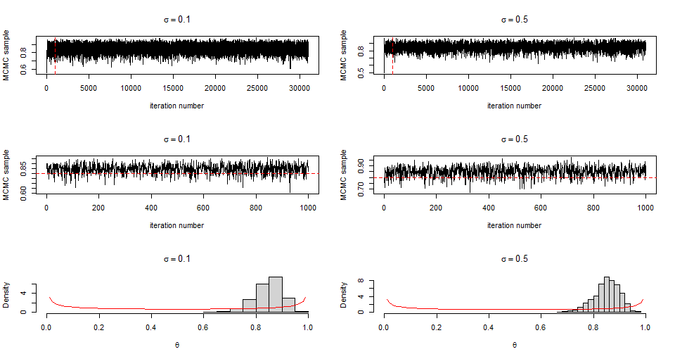

|  |  |  |  |
| --- | --- | --- | --- |
|  | E(theta|y) | Var(theta|y) | AR |
| sigma=0.1 | 0.8480974 | 0.0027426 | 0.5382903 |
| sigma=0.5 | 0.8502182 | 0.0022889 | 0.2091613 |

由上表可知，𝜎=0.1和𝜎=0.5的E(theta|y) 都接近0.8，但當𝜎=0.1時，AR明顯高於𝜎=0.5， 因為後驗分配是在有樣本下對先驗分配的修正,但先驗分配假設過於主觀(變異數很小，theta會收斂至其期望值)造成與後驗分配差異大。

# 2

Generate a sample of size m=1000 from $f_{Y}(y)$

m=1000=N;k=30

Algorithm:

Step1: Specify $y_{0}=0.5$

Step2: Generate $x_{0}∼Bin(n,y_{0})$

Step3: n=1

Step4: $y_{n}∼Beta(x_{n-1}+α,n-x_{n-1}+β)$

Step5: $x_{n}∼Bin(n,y_{n})$

Step6: n=n+1, go to Step4 after m+N*k itrations

Step7: Set $x_{i}^{*}=x_{m+ik}, y_{i}^{*}=y_{m+ik}, i=1,...,N$.

E(Y) $≈\frac{1}{N}\sum_{i=1}^{N}{y_{i}^{*}}$, Var(Y) $≈\frac{1}{N-1}\sum_{i=1}^{N}{(}y_{i}^{*}-E(Y))^{2}$, $\hat{f_{Y}}(y)=\frac{1}{N}\sum_{i=1}^{N}{f}(y|x_{i}^{*}),y=0.01,0.03,...,0.99$

#2  
y0 <- 0.5  
N = m = 1000;k <- 30  
x <-c(); y <- c()  
set.seed(109225017)  
for(i in 1:(m+N*k)){  
 x[i] <- rbinom(1,20,y0)  
 y[i] <- rbeta(1,x[i]+2,20-x[i]+4)  
 y0 <- y[i]  
}  
result <- y[seq(m+k,m+N*k,k)]  
xaxis <- seq(0.01,0.99,0.02)  
fyhat <- sapply(xaxis, function(y){  
 mean(dbeta(y,x[seq(m+k,m+N*k,k)]+2,20-x[seq(m+k,m+N*k,k)]+4))  
})  
plot(xaxis,fyhat,type = "l",xlab = "y",ylab =expression(hat(f)))

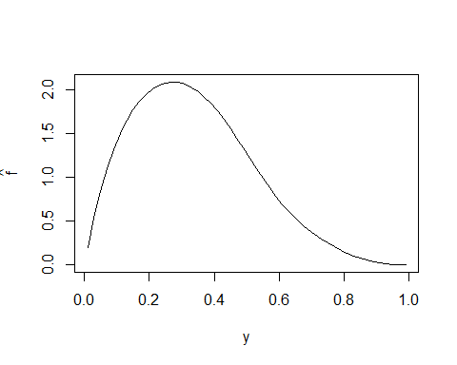

mean(result);var(result)

## [1] 0.3358946

## [1] 0.03205318